***Contains spoilers for kata 'Make Techno'***
The following screenshots show what the Sensei's 'create kata' page should look like. There are two examples.

Example 1
Complete Solution tab: put your complete solution here.
Test Cases tab: put your 'random tests' code here. The code can go after your usual tests. Make sure you are calling your methods/functions here too.
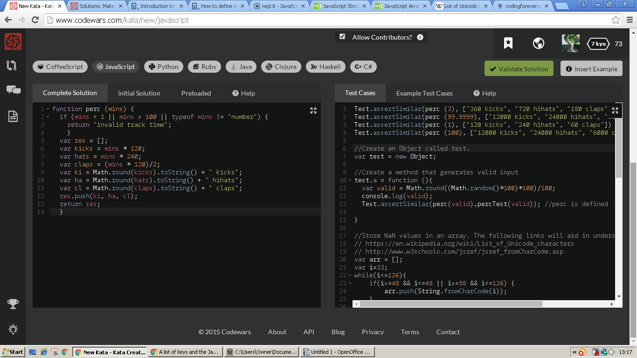
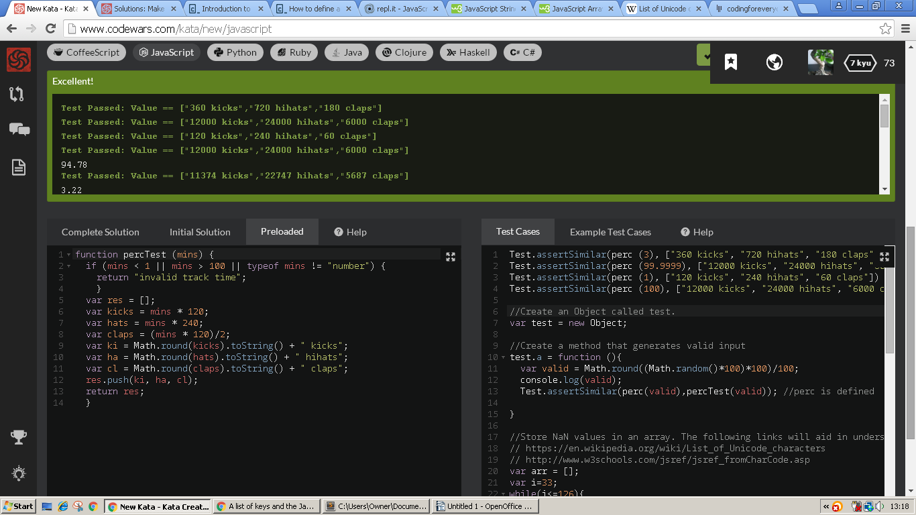
Preloaded solution tab: put a copy of your solution in here but give the function a different name to the one in the Complete solution tab.

Example 2:
The code for your random tests can also go in the Preloaded area. You just need to call your methods in the Test Case area.
Note that this works because I am using an Object to store my random tests.
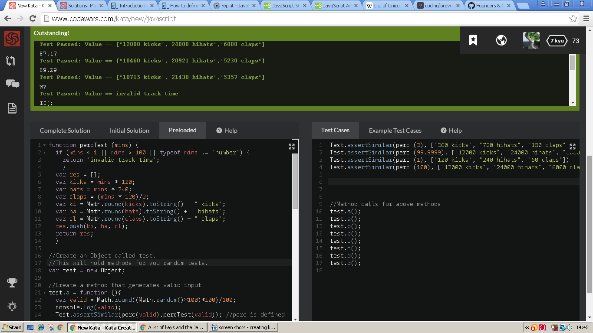
Preloaded tab: contains a copy of your solution and the 'random tests' code.
Test Case tab: put your original tests here and also your method calls.

